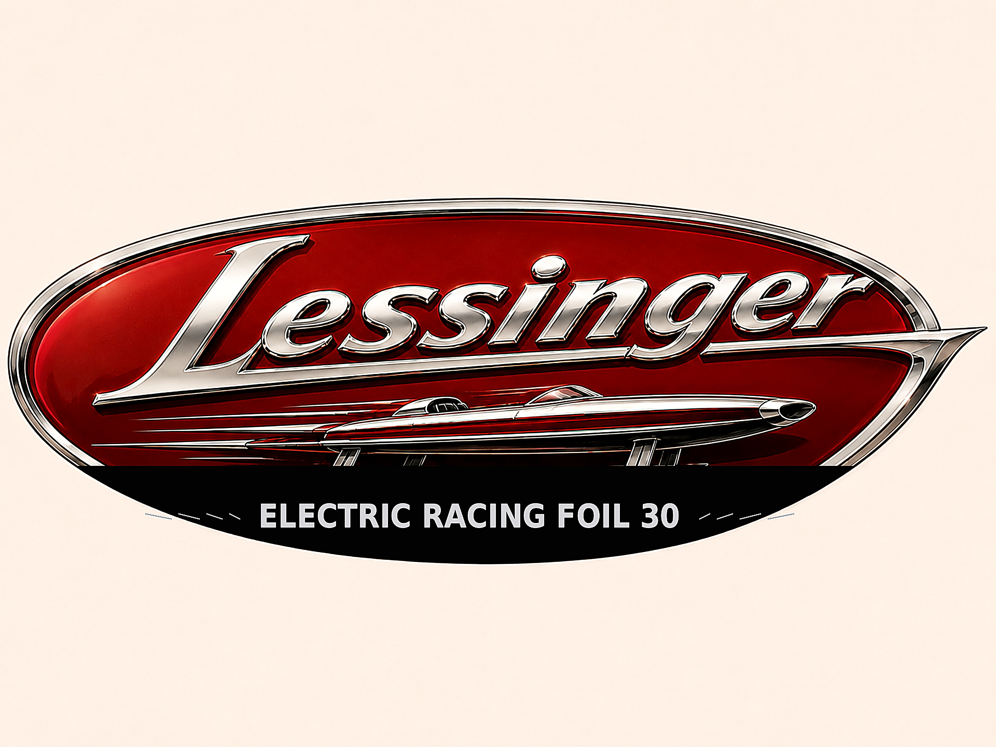
LESSINGER
ELECTRIC HYDROFOIL MOTOR BOAT 30
FREQUENTLY ASKED QUESTIONS
TOP SPEED  27–30 kt | CRUISING SPEED  20–22 kt | CAPACITY  Up to 6 people

ENGLISH
Frequently Asked Questions
Professional English version

Performance and charging
01. What is the top speed?
The LESSINGER Electric Hydrofoil Motor Boat 30 can reach a top speed of 27 to 30 knots. Its cruising speed is between 20 and 22 knots.
02. What is its range?
At cruising speed, the stated operating time is 2 to 3 hours, corresponding to approximately 45 to 60 nautical miles.
03. How long does it take to fully recharge the batteries?
With an 80 kW fast charger, charging from 0 to 100% takes approximately 1 hour to 1 hour 15 minutes.

Handling and safety
04. Is the boat suitable for beginners?
Yes. Its controls are designed to be intuitive for both first-time foilers and experienced riders.
05. What safety equipment is included?
an automatic shut-off system;
a navigation system with GPS/chartplotter, speed display and heading information;
a depth sounder showing the water depth beneath the boat;
navigation lights for visibility and for indicating the vessel’s direction of travel at night;
a paddle and a bailer;
six life jackets.
06. How does the hydrofoil technology work?
The foils lift the hull above the water using a principle similar to an aircraft wing. This reduces drag, improving energy efficiency and speed.
07. How does the boat handle in rough water?
The hydrofoil system provides good stability and handling when sea conditions remain relatively calm. As waves become larger, the boat should be flown lower to prevent foil ventilation and the hull dropping back onto the water.
08. What is the boat’s payload capacity?
The stated maximum payload is approximately 500 kg, with capacity for up to six people.

Construction and environment
09. What materials are used in its construction?
The boat is built entirely from carbon fibre, combining strength, light weight and durability.
10. Is the boat environmentally friendly?
Its propulsion system is fully electric and produces no direct emissions during operation.
11. Can it be used in both salt water and fresh water?
Yes. The boat is designed for use in both salt water and fresh water. However, it is recommended that the boat be removed from the water after each use and rinsed with fresh water, particularly to reduce the risk of corrosion.
12. How durable is its construction?
Its all-carbon-fibre construction provides high durability and strong resistance to wear from regular use.
13. How quiet is the electric propulsion system?
The electric propulsion system is very quiet. Most of the sound comes from the rotating motor and the lower reduction gear, both of which are located below the waterline.

Maintenance, storage and customisation
14. What maintenance is required?
Maintenance is comparable to that of a conventional boat. The boat should be removed from the water between uses, rinsed with fresh water after every trip in salt water, and its main compartments and components checked regularly.
15. Are there any storage compartments?
Yes. The forward battery compartment can hold small personal items. Additional storage is provided at the stern beneath the swim platform. Heavy items should be avoided, as they may affect the boat’s balance and foiling behaviour.
16. Are customisation options available?
Yes. Several options are available for the colour, upholstery and selected accessories.
17. Is the boat easy to transport?
Yes. Its design allows it to be transported on a trailer or carried aboard a larger vessel.

